Mathematical Task
Item Required
- 1.Pen
- 2.Papper
- 3.Calculater
- 4.Graph
- 5.Mathametical formula (Single Linear Regression)

Single Linear Regression.
y = mx + c
Where:
- y = Predicted value (output)
- x = Input value
- m = Slope
- c = Intercept
Let us derive it mathematically using sample student data.

Study Hours (x) | Marks (y)
1 | 35
2 | 45
3 | 55
4 | 65
5 | 75

m = ?
c = ?

Step 1: Formula for slope (m)
$$m=\frac{n∑xy-(∑x)(∑y)}{n∑x^{2}-(∑x)^{2}}$$

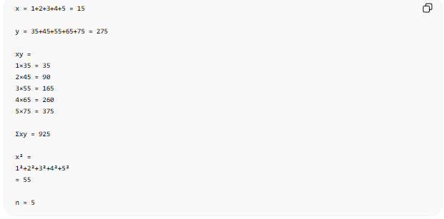
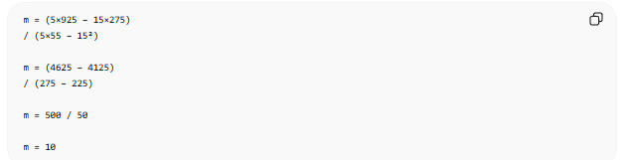

Step 2: Find intercept (c)
Formula:
$$c=\frac{∑y-m∑x}{n}$$

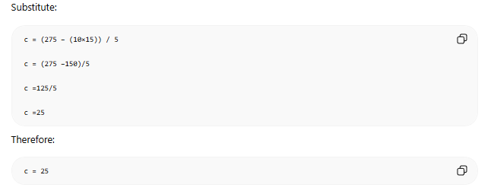

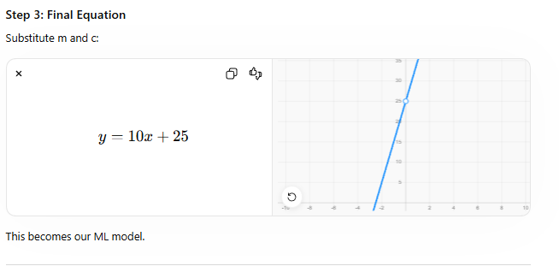

Step 4: Prediction
Suppose student studies:
x = 6 hours
Put into equation:
y = 10(6)+25
y = 60+25
y = 85
Prediction:
6 study hours → 85 marks

Flow students can understand
Historical Data
↓
Calculate m
↓
Calculate c
↓
Build equation
↓
y = mx + c
↓
Predict future values

